**Title of the Project:** Toy Ordering and Selling System

**Name:Akhil Kumar Reddy**

**GitHub Link:**

**Specific Product**

The company builds underwater-themed action figures from a popular Anime/ cartoon aimed at kids. Hence, the product that my company “***Tank Toy***” would sell Scuba Tank Toys to the aforementioned retail company.

**Short Description of Business**

Our enterprise manufactures and distributes Scuba tank toys to other vendors to generate our business revenue. Our business follows the business-to-business marketing concepts as both actors are enterprises or large organizations. We have advanced versions of cylinder pressing facilities which have been designed by our highly skilled engineers. Therefore, the mechanism of using this oxygen tank toy is so simple that a layman can learn it within a few moments. Likewise, our sales and marketing team communicates with other vendors in order to finalize the deal.

**Size of Organization**

The total size of the workforce of our organization is 50 where manufacturing and marketing departments are highest.

**General Locations**

The general locations of our offices as well as manufacturing units are the city area of Australia and the Capital city of Asian countries.

**Annual Sales Growth**

The annual sales growth of our organization is $20 Billion to $30 billion.

**2. Comparison of “Tank Toy” Business with Real One**

| **Tank Toy** | **Moose Toys** |
| --- | --- |
| 1. Name of the business: Toy Manufacturing and Distribution | 1. Name of the business: Toy Manufacturing and Distribution |
| 2) Sales in the year 2021 is $25 Billion | 1. Sales in the year $30 million |
| 1. The number of employees is 50. | 3) The number of employees is 100. |

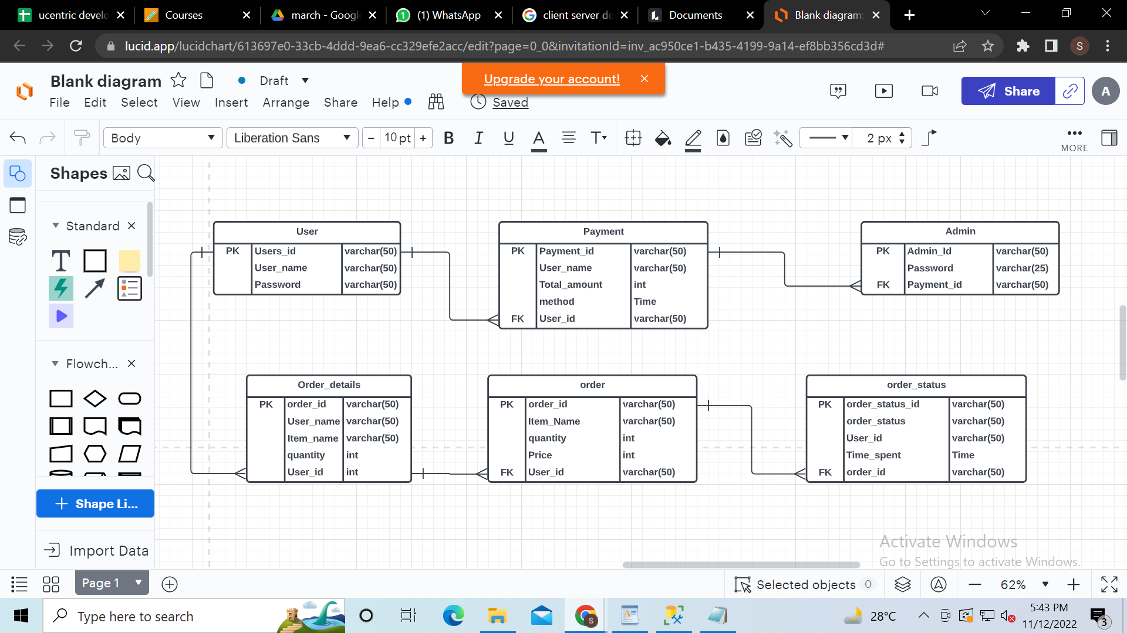



In the above diagram i mention two tools that is request response.The Request Response tools are perform the Data translation one system to another system(one country to another country).Basically our main country is USA which is perform a Server and country perform as a client.First if any country need product this country request to the server which is USA.and the server which is USA provide response to the client company which in outside the USA.

The tools are server, request,response,client and Database.

Data format that transforms the Data from one machine to another machine which is XML,CSV,Json,sql,and text base.

**URL:** <https://incfact.com/company/moosetoys-elsegundo-ca/>